# Power BI Developer Setup Guide

**Setup Time**: 60 minutes

**Setup Overview**: These setup instructions walk through the steps required to configure a Windows PC or a virtual machine (VM) that will be used by students when working on the lab exercises for **Power BI Dev Camp**.

### Install and Configure Windows 10 or Windows 8.1

In this step you will install the Windows operating system and enable the execution of PowerShell scripts using Windows PowerShell.

1. Install the x64 bit edition of Windows.
   1. You can install either Windows 10 or Windows 8.1 to complete lab exercises.
   2. Apply all Windows updates.
2. Install the Chrome browser.
   1. You should be able to access the Internet with Chrome and at least one other browser (e.g. Microsoft Edge).
3. Enable the execution of Windows PowerShell scripts on your local PC.
   1. Open a Windows PowerShell command shell running as Admin and type in and execute the following PowerShell command.

Set-ExecutionPolicy Bypass -Scope CurrentUser

* 1. When prompted to confirm to the operation, type **Y** and press **ENTER** to confirm that you want to enable script execution.

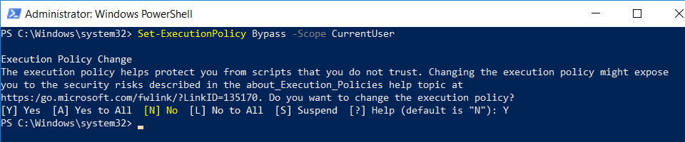

You should now be able to execute PowerShell scripts on your computer using Windows PowerShell 5.

### Install the Azure AD PowerShell Modules for Windows PowerShell 5

In this task you will install the Windows PowerShell library for Azure AD which will be used to create Azure AD applications.

**NOTE**: if you are running Windows 8.1, you must first install the Windows Management Framework 5.1 which is covered in step 1 below. If you are running Windows 10, you can skip step 1 and move to step 2 below.

1. If you are running Windows 8.1, download and install the Windows Management Framework 5.1using the following link.

<https://www.microsoft.com/en-us/download/details.aspx?id=54616>

1. Install the Azure PowerShell modules by executing the following PowerShell commands one at a time in the PowerShell console.
   1. In the PowerShell console, execute the following command

Install-PackageProvider -Name NuGet -MinimumVersion 2.8.5.201 -Force

* 1. Next, execute the following command to trust the PowerShell gallery.

Set-PSRepository -Name PSGallery -InstallationPolicy Trusted

* 1. Next, execute the following command to install the Azure Active Directory PowerShell cmdlets library.

Install-Module AzureAD -AllowClobber -Force

* 1. Finally, execute the following command to install the Power BI cmdlets library.

Install-Module MicrosoftPowerBIMgmt -Force

* 1. Wait until the installation has completed.

### Install the GIT Command-line Utility

In this exercise, you will install the **git** utility. The reason for installing this utility is that it will be used to download projects from GitHub.

1. Install the GIT command-line utility
   1. Launch a browser and navigate to the following link.

<https://git-scm.com/download>

* 1. Download the installation files for git for Windows.

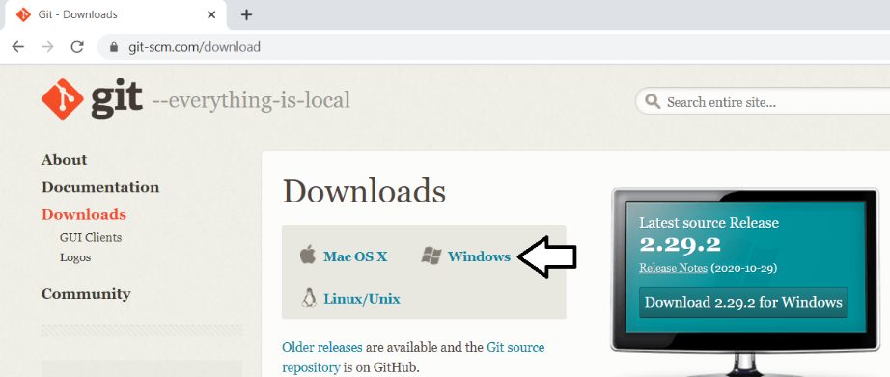

* 1. Run the installation program. When prompted, agree to the terms and accept all the default settings.

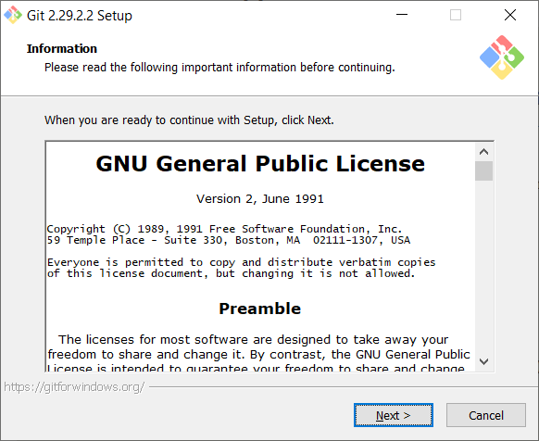

* 1. You can accept the default settings for each page in the setup wizard.
  2. Click **Next** on each page in the setup wizard until the installation begins
  3. Wait until the installation is complete.

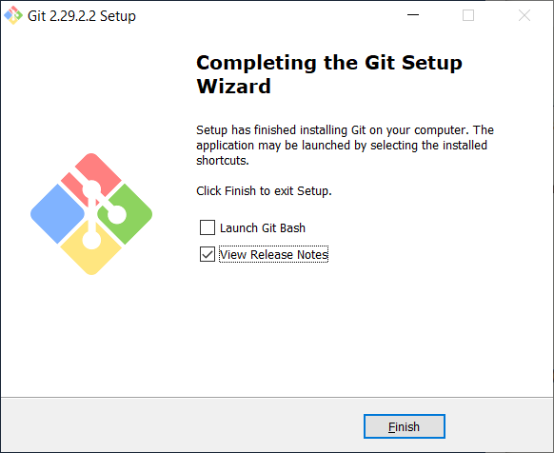

### Install the .NET 5 SDK

In this exercise, you will install the .NET 5 SDK which makes it possible to create and debug .NET 5 application.

1. Download the .NET 5 SDK
   1. In the browser, navigate to the following page

<https://dotnet.microsoft.com/download/dotnet/5.0>

* 1. Download the Windows 64-bit edition of the .NET 5 SDK and once it downloads, begin the installation.

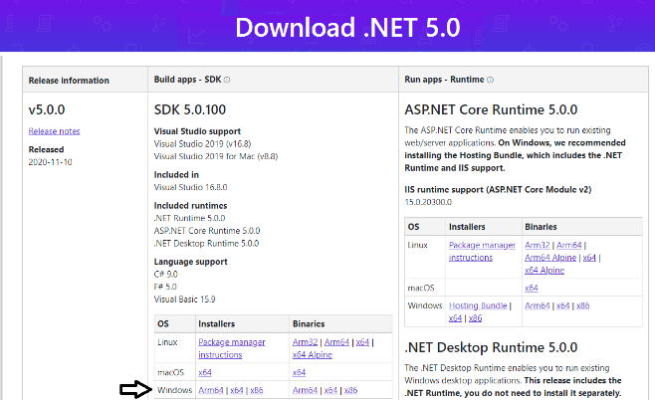

The User Installer file for 64-bit Windows is named **dotnet-sdk-5.0.100-win-x64.exe**.

* 1. When the .NET 5 installer program runs, it prompts you with a dialog. Click **Install** to continue.

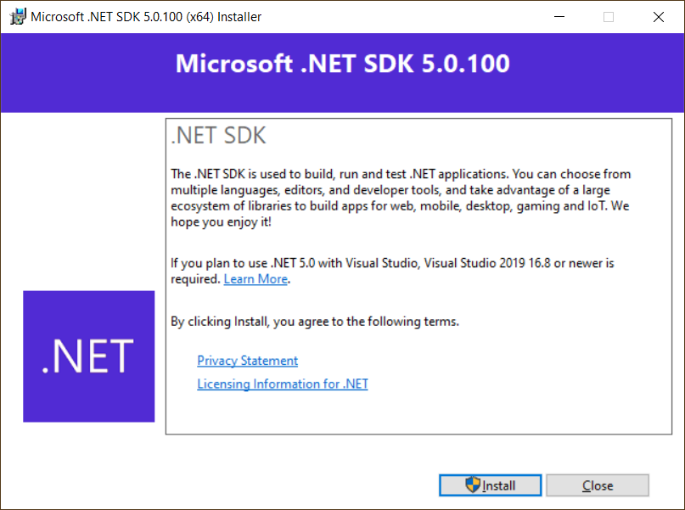

* 1. When the installation completes, you'll see a dialog that tells you what was installed. Click **Close** to complete the installation.

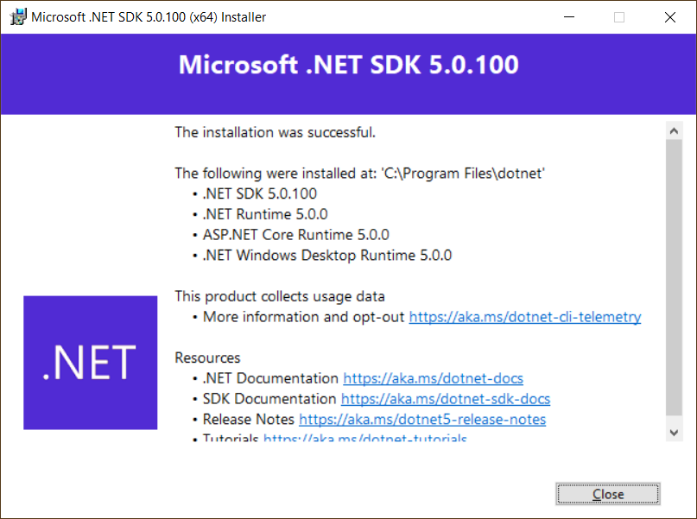

### Install Node.js Version

In this task, you will install Node.js. Node.js is a development platform used to create many different types of development projects.

1. Download the MSI file to install the latest release of Node.js.
   1. Navigate to the web page at the following URL..

<https://nodejs.org>

* 1. You should see a folder of files installation files similar to the folder shown in the following screenshot.

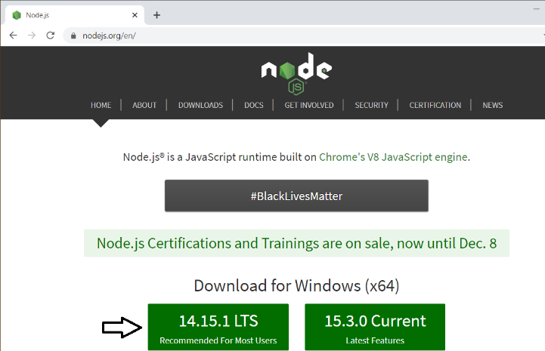

* 1. Click on the button to install the most recent LTS version of Node.JS.
  2. Once you have downloaded the **MSI** file installer, run it to begin the Node.js installation program.
  3. When you see the Node.js Setup Wizard's Welcome screen, click **Next**.

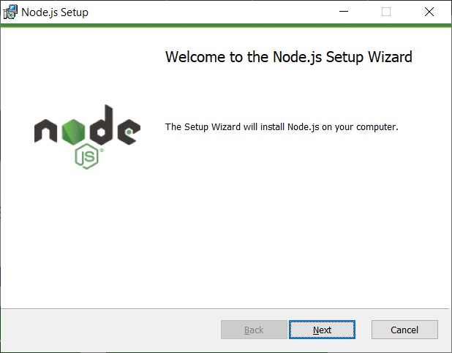

* 1. Agree to terms and click **Next**.
  2. Accept (or modify) the installation folder and click Next.
  3. On the **Custom Setup** page, accept the default setting and click **Next**.

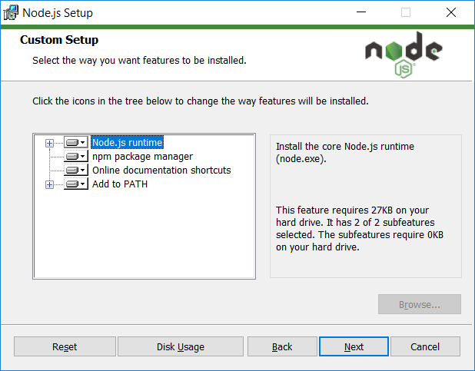

* 1. On the **Ready to install Node.js** page, click **Install** to begin the installation.

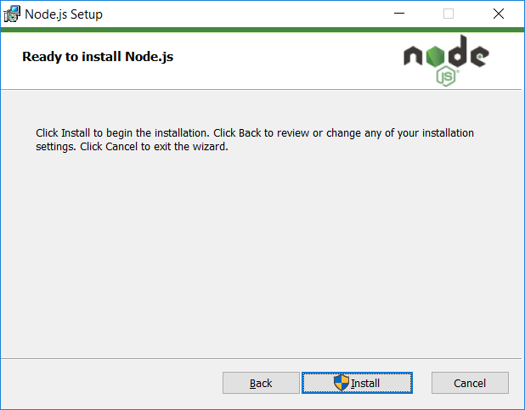

* 1. Wait until the installation completes and then click **Finish**.

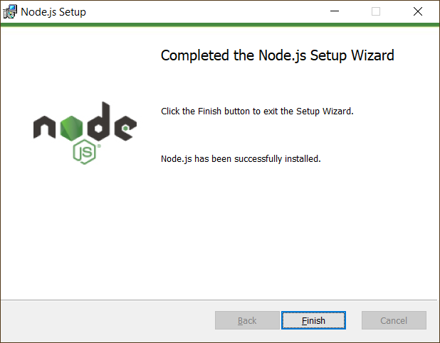

1. Launch the Node.js command prompt.
   1. In the Windows Start menu, locate and select the **Node.js command prompt**.

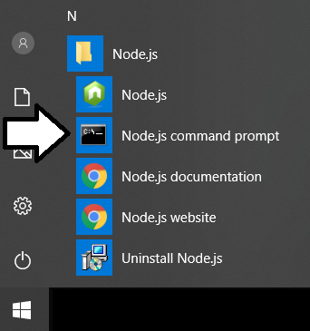

* 1. Verify the the Node.js command prompt launches without error. Note you can see the current Node.js version number.

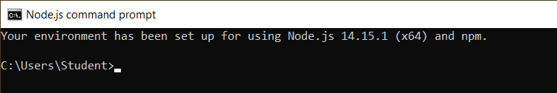

### Install Visual Studio Code

In this setup task, you will install Visual Studio Code.

1. Launch a browser and navigate to the following link.

<https://code.visualstudio.com/download>

1. Download the Windows 64-bit User Installer for Visual Studio Code.

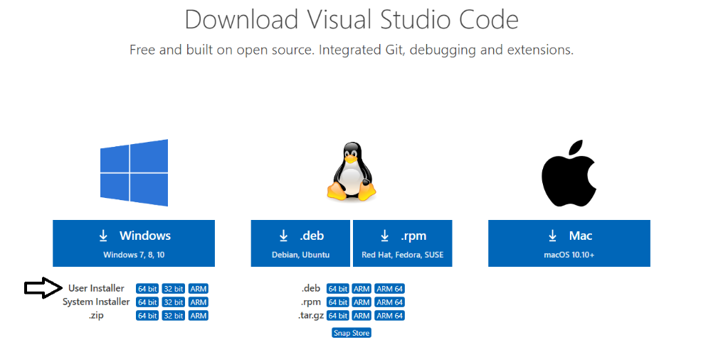

1. Run the installation program for Visual Studio Code.

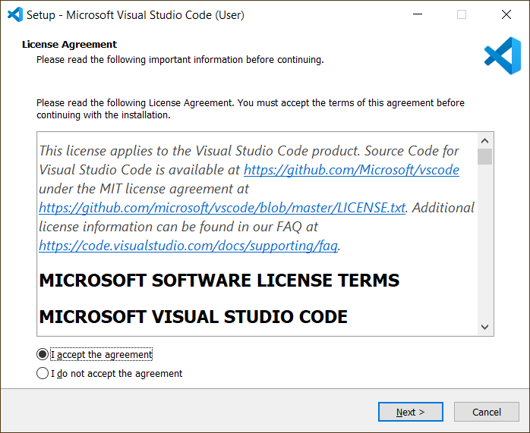

1. When you get to the **Select Additional Tasks** dialog, select all options and click **Next** to continue.

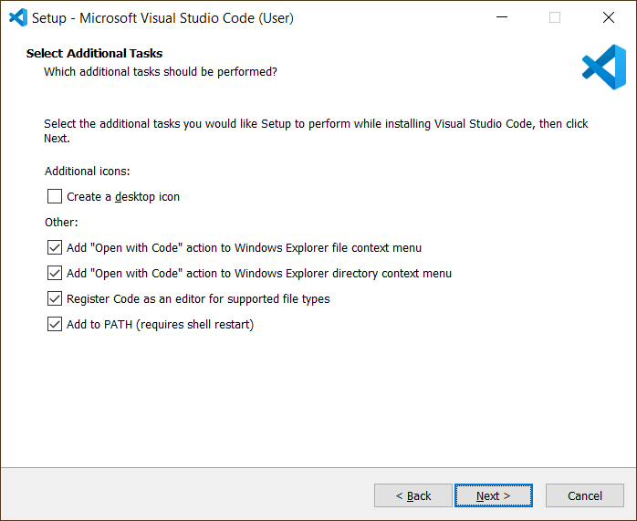

1. When you get to the **Ready to Install** dialog, click **Next** to continue.

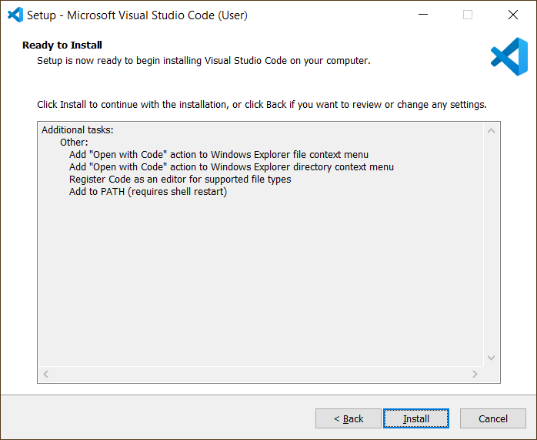

1. Move through the installation program dialogs until you reach the **Completing the Visual Studio Code Setup Wizard** dialog.
2. Click **Finish**.

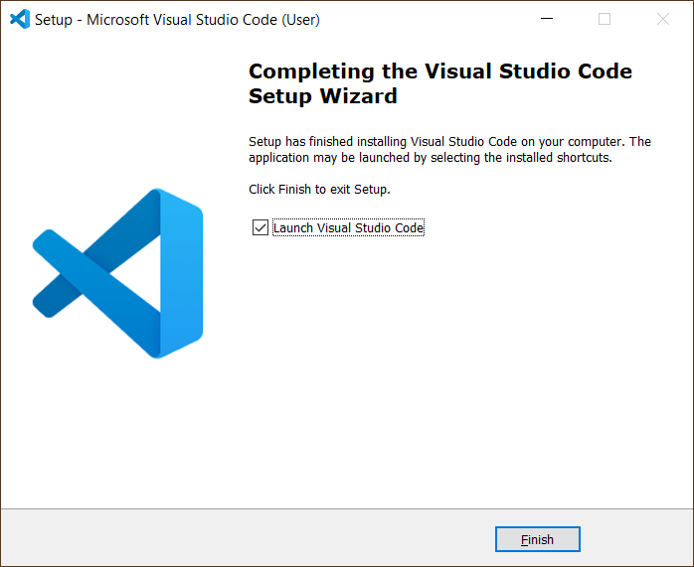

1. When the installation program completes, it should launch Visual Studio Code.

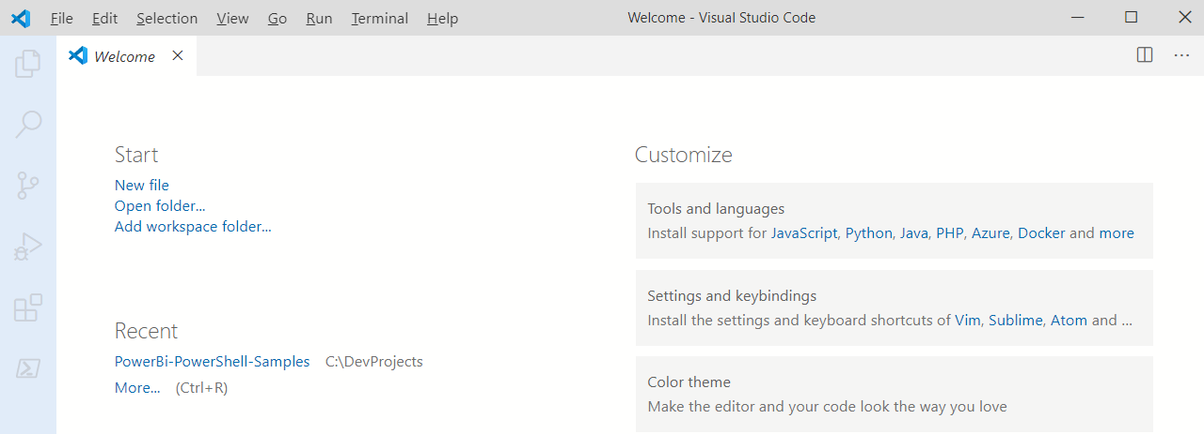

### Install Visual Studio 2019

In this exercise, you will install Visual Studio 2019 Professional. Note if you don't have access to Visual Studio 2019 Professional, you can complete all of the labs instead using the free version of Visual Studio 2019 community edition.

**NOTE**: If you already have Visual Studio 2019 installed, you must update to version 16.8 in order to develop with the .NET 5 SDK.

1. Obtain the installation software for Visual Studio 2019 – You can use the Professional edition or the Community edition.
   1. Navigate to <https://visualstudio.microsoft.com/downloads/>
   2. Download the installer for the Community edition or the Professional edition.

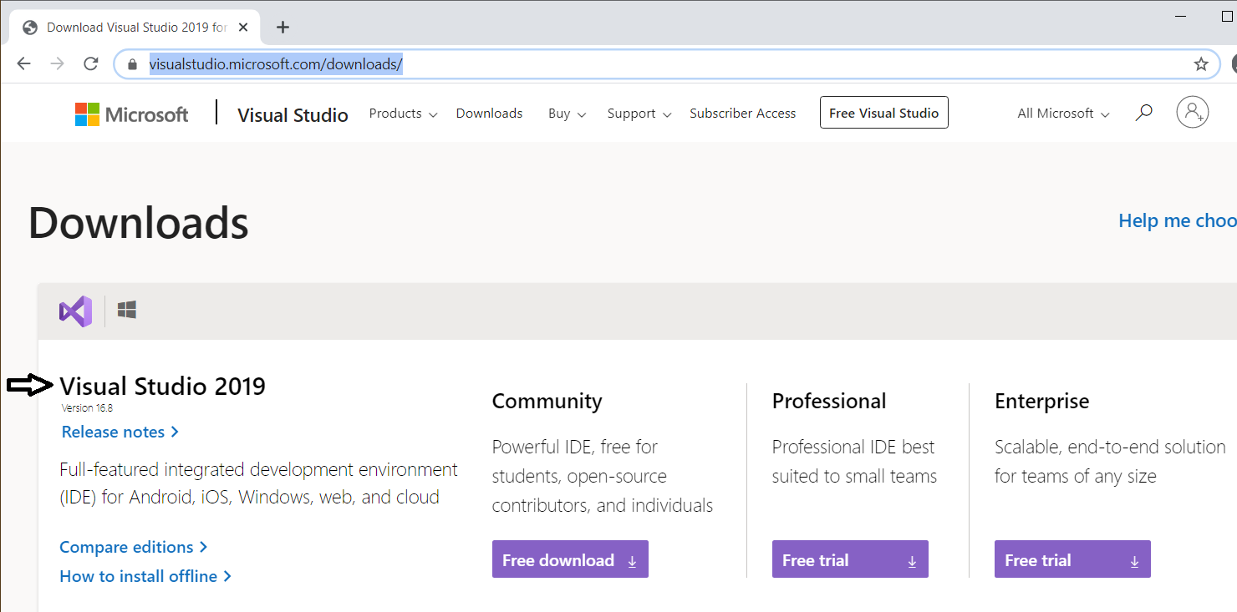

The Community edition is free. The Professional version is not free, but you can download and install a 30-day trial.

* 1. Once the installation begins you are prompted with a dialog. Click **Continue** to run the installation program.

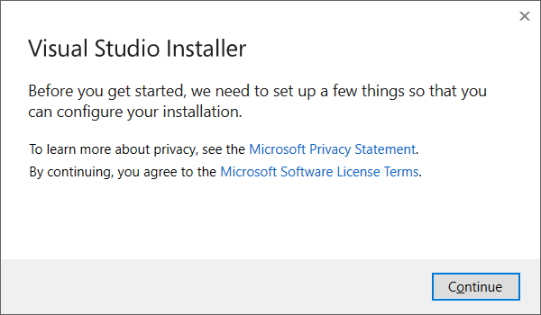

* 1. Under **Workloads** tab in the **Web & Cloud** section, select the following workloads
     1. ASP.NET and web development
     2. Azure Development

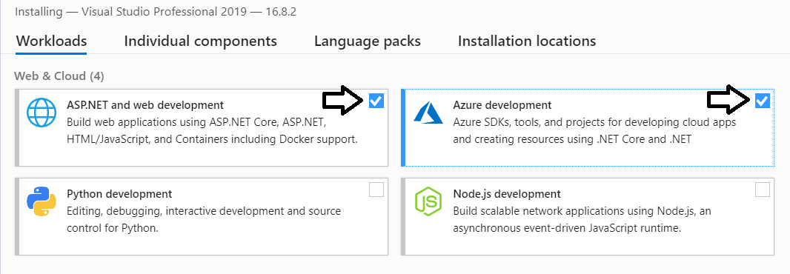

* 1. Under **Workloads** tab in the **Desktop & Mobile** section, select the following workloads
     1. .NET desktop development

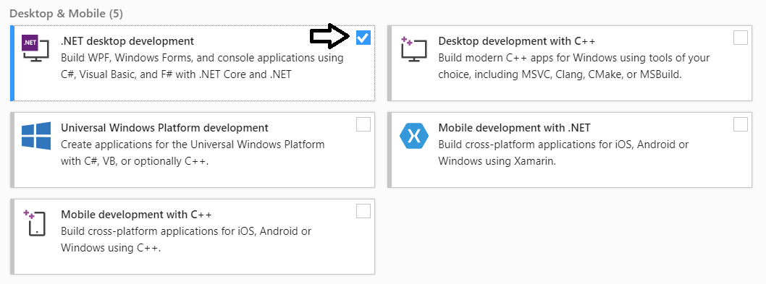

These instructions indicate which workloads you need to install in order to complete Power BI Dev Camp lab exercises. However, you should feel free to install any other workloads you need or you'd like to try out.

* 1. Move ahead in the installation program to the **Summary** section.
  2. Locate and click the Install button in the bottom right corner to begin the installation.

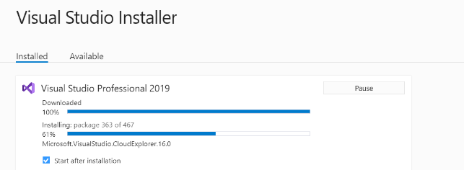

The installation will take about 20-30 minutes to complete.

1. When the installation is complete, you will see the a page telling you that Visual Studio 2019 has been installed.

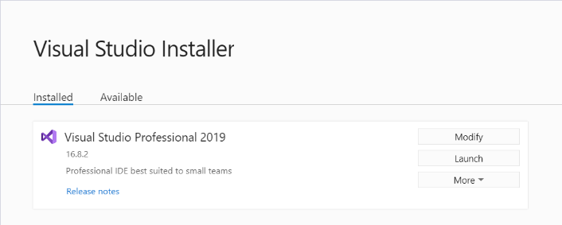

1. Launch Visual Studio 2019.
   1. When you see the **Welcome** screen, it will prompt you to sign into Visual Studio Online. However, there is no need for you to log onto Visual Studio Online. Instead, click the **Not now, maybe later** link at the bottom of the **Welcome** screen



* 1. On the next screen, select a Development Setting for the color theme and then click **Start Visual Studio**.

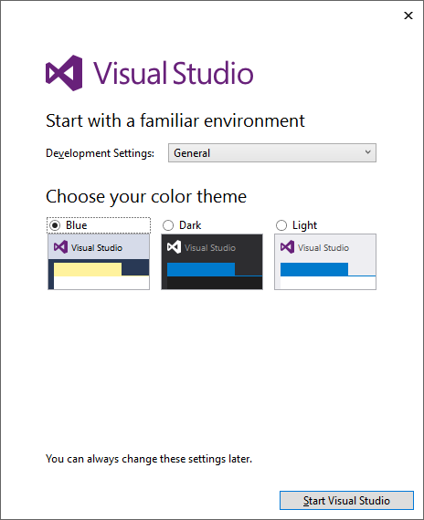

* 1. Once Visual Studio has started, you can close it down as the installation is now complete.

### Install Fiddler

In this exercise, you will install the Fiddler developer utility.

1. Launch a browser and navigate to the following link.

https://www.telerik.com/download/fiddler

1. Download the installation files for Fiddler.



1. When the Fiddler installation program starts, it prompts you to accept the licensing agreement. Click **I Agree**.

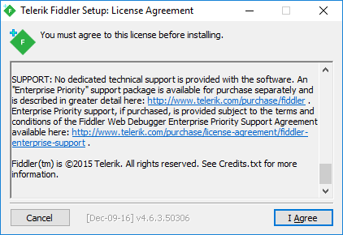

1. Next, click the **Install** button to run the Fiddler installation program.

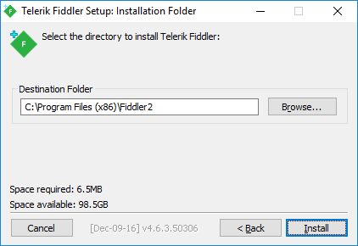

1. When the Fiddler installation program completes, launch Fiddler from the Windows Start menu.



Steps 6, 7 and 8 only apply if you are using Windows 10. If you are using Windows 8.1, you can skip ahead to step 9.

1. When Fiddler starts for the first time, it prompts you with the **AppContainer Configuration** dialog. Click the **Cancel** button to dismiss the dialog and prevent this dialog from reappearing later.

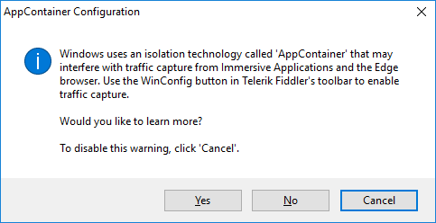

1. Once Fiddler has started, click the **WinConfig** button in the toolbar in the top left-hand corner of the Fiddler window to display the **AppContainer Loopback Exemption Utility** dialog.



1. In the **AppContainer Loopback Exemption Utility** dialog, select Microsoft Edge on the left and then click **Save Changes**.



1. Configure Fiddler support inspecting HTTPS request that are using SSL.
   1. Select the **Tools > Options…** command

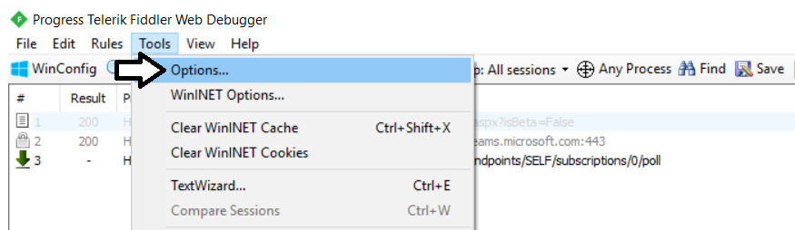

* 1. On the **General** tab of the **Options** dialog, uncheck the **Notify me for updates on startup** checkbox.



* 1. On the **HTTPS** tab of the **Telerik Fiddler Options** dialog, check the **Decript HTTPS traffic** checkbox.



* 1. Click **Yes** when prompted whether to **Trust the Fiddler Root Certificate?**

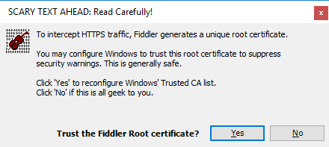

* 1. Click **Yes**, when you see the following dialog which asks **Do you want to install this certificate**.

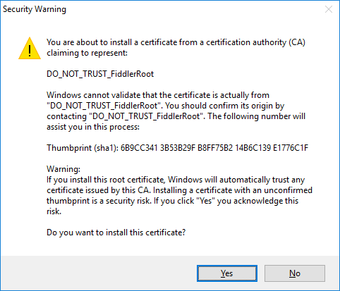

* 1. Click **Yes** one more time when you see the **TrustCert Confirmation** dialog.

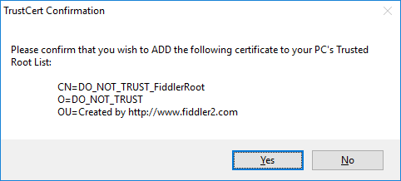

* 1. You should now see a dialog that confirms that Fiddler's root certificate has been added to the machine root list.

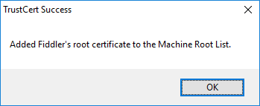

* 1. Select **Ignore server certificate errors (unsafe)** and then click **OK** to dismiss the **Options** dialog.

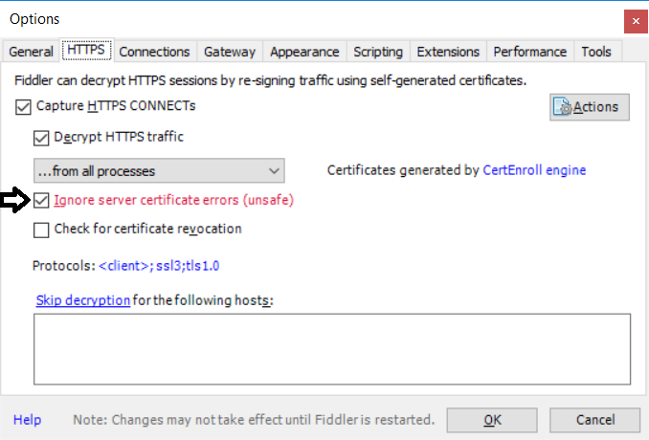

1. Test out Fiddler.
   1. Close and restart Fidler.
   2. Launch the Chrome browser and navigate to a URL with SSL such as <https://google.com>.
   3. Make sure you can use Fiddler to monitor HTTPS request.

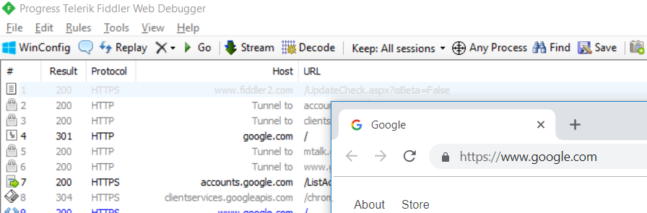

* 1. If you are using Windows 10, launch the Microsoft Edge browser and navigate to a URL with SSL such as <https://bing.com>.
  2. Make sure you can use Fiddler to monitor HTTPS request.



### Install Power BI Desktop

In this setup task, you install Power BI Desktop if you don't already have it installed or you need an updated version.

1. Download the EXE installation file for Power BI Desktop.
   1. Using the browser, navigate to the following URL.

<https://aka.ms/pbiSingleInstaller>

* 1. Move down the web page and locate the **Microsoft Power BI Desktop** section.

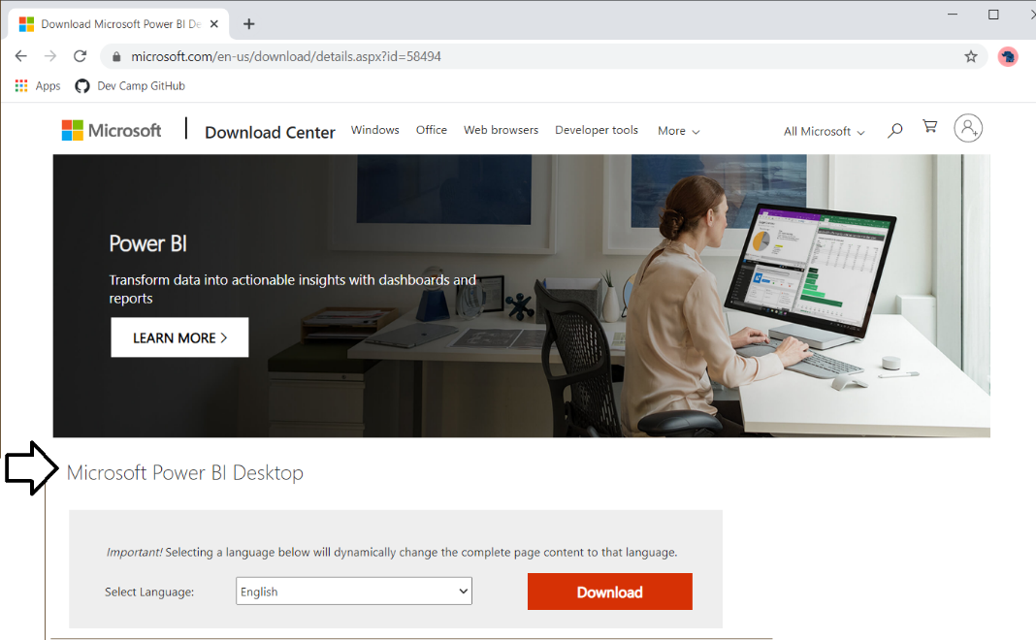

* 1. Click the Download button to download the EXE-based installation program for Power BI Desktop.

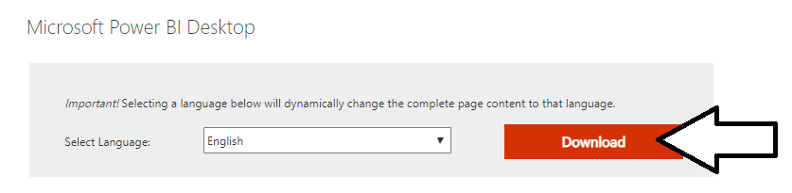

* 1. Click the checkbox to download the 64-bit version.
  2. Click **Next** to download the installation file named **PBIDesktopSetup_x64.exe**.

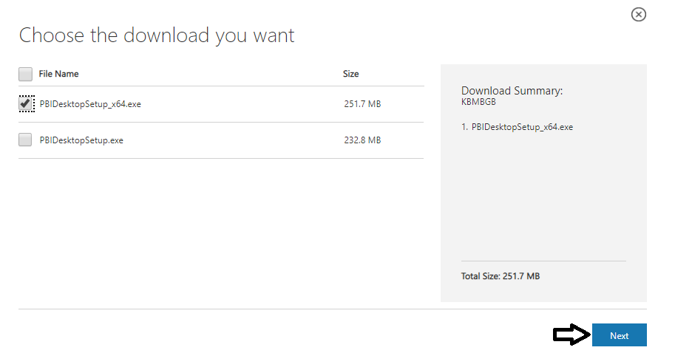

* 1. Wait until **PBIDesktopSetup_x64.exe** has finishing downloaded

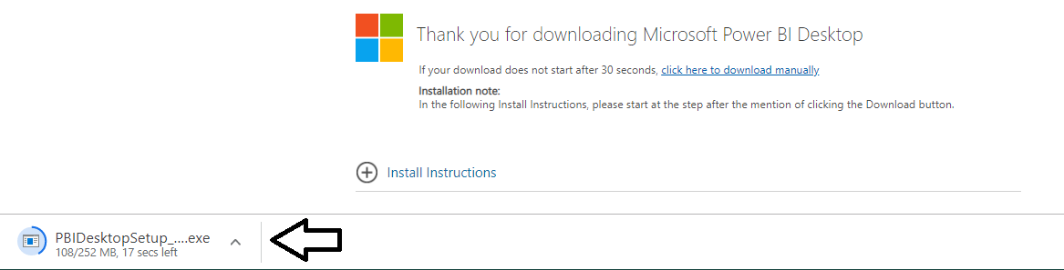

1. Select **Open** on **PBIDesktopSetup_x64.exe** to begin the installation of Power BI Desktop.

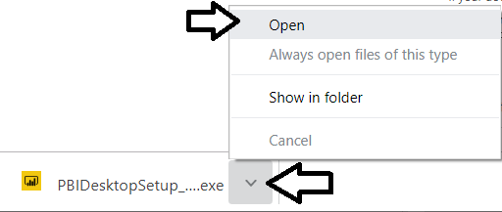

* 1. When you see the Welcome screen, click **Next** to continue with the installation.

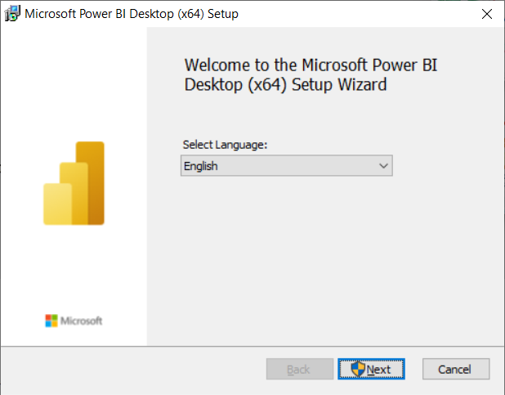

* 1. Click **Next** again to move past the Welcome screen.

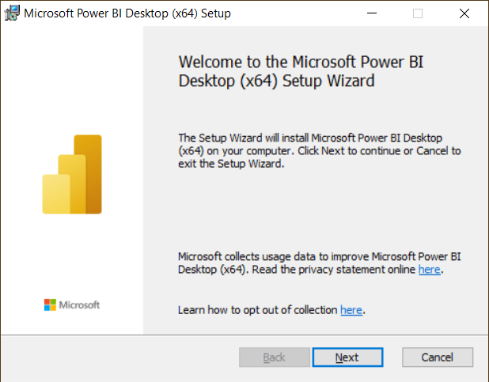

* 1. Click the checkbox to accept the license agreement and click **Next**.

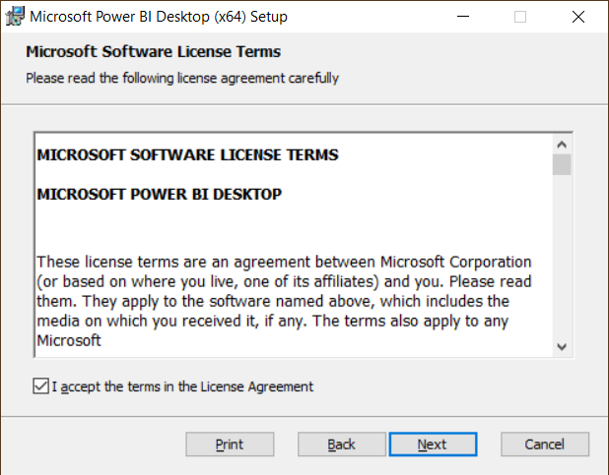

* 1. On the **Destination Folder** page, click **Next** to continue.

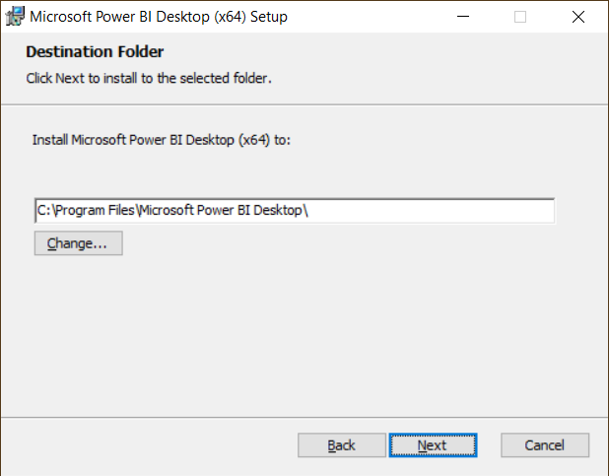

* 1. On the **Ready to install** page, click **Install** to begin the installation.

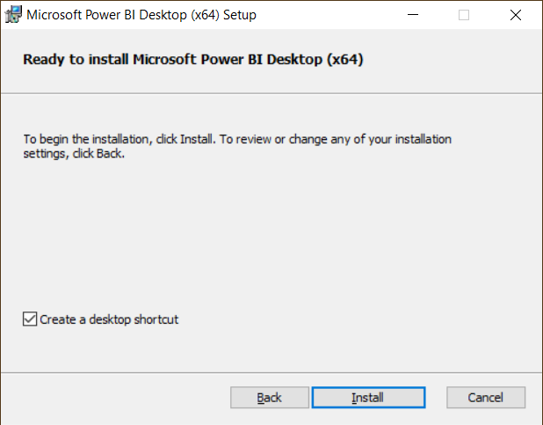

* 1. When you see the **Completed** dialog, click **Finish** to complete the installation and launch Power BI Desktop.

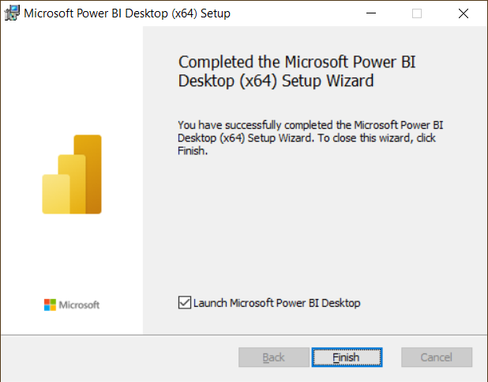

* 1. When Power BI Desktop starts, close the Welcome screen by clicking the **X** in the upper right corner.

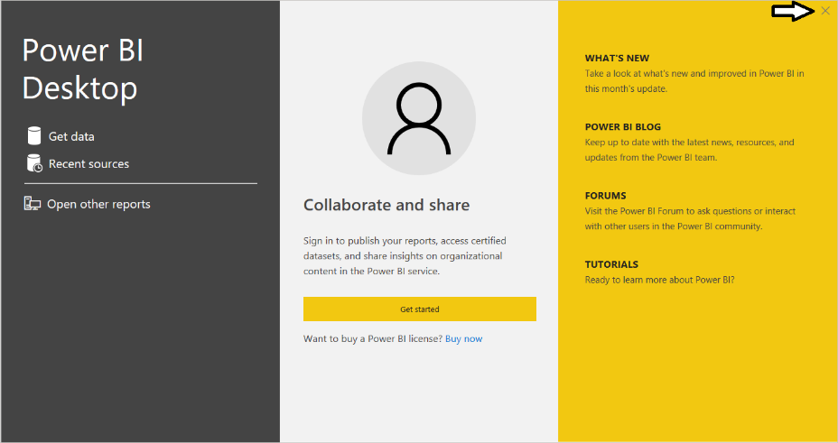

* 1. You should now have a working installation of Power BI Desktop.

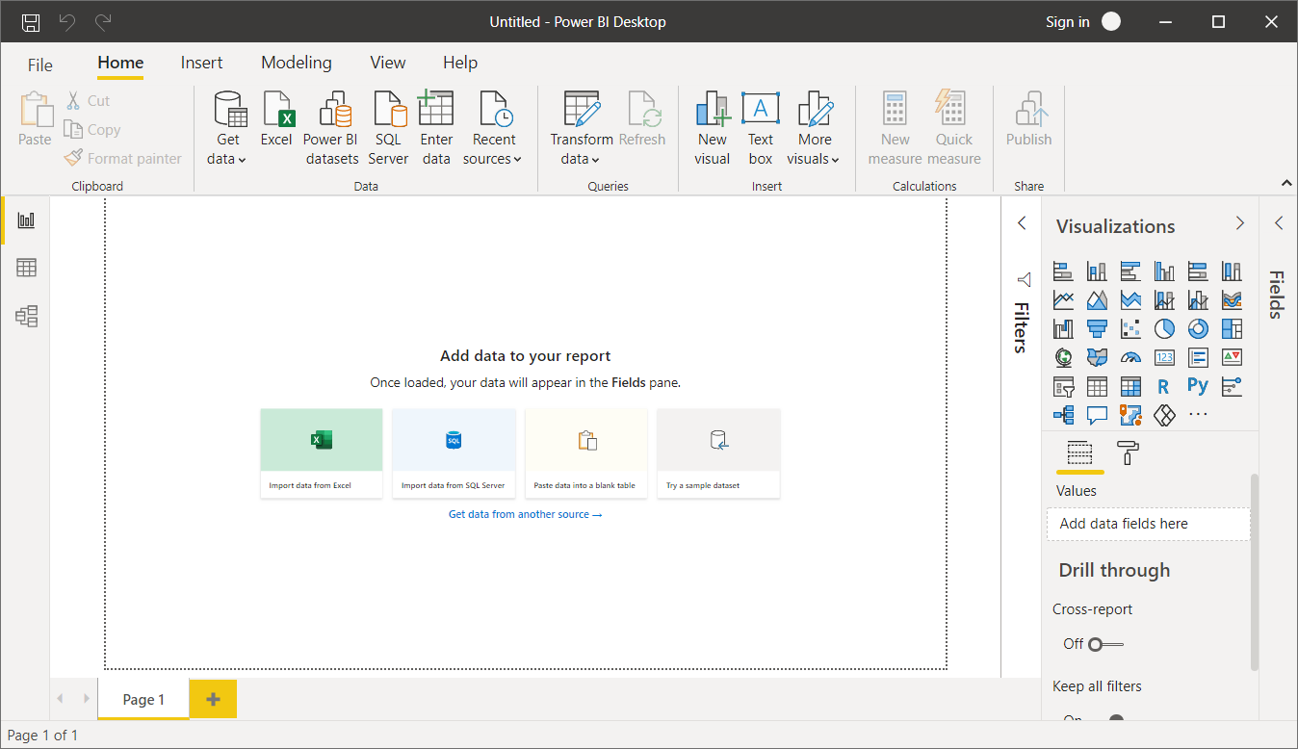

You have now installed all the software required to complete lab exercises for Power BI Dev camp.